[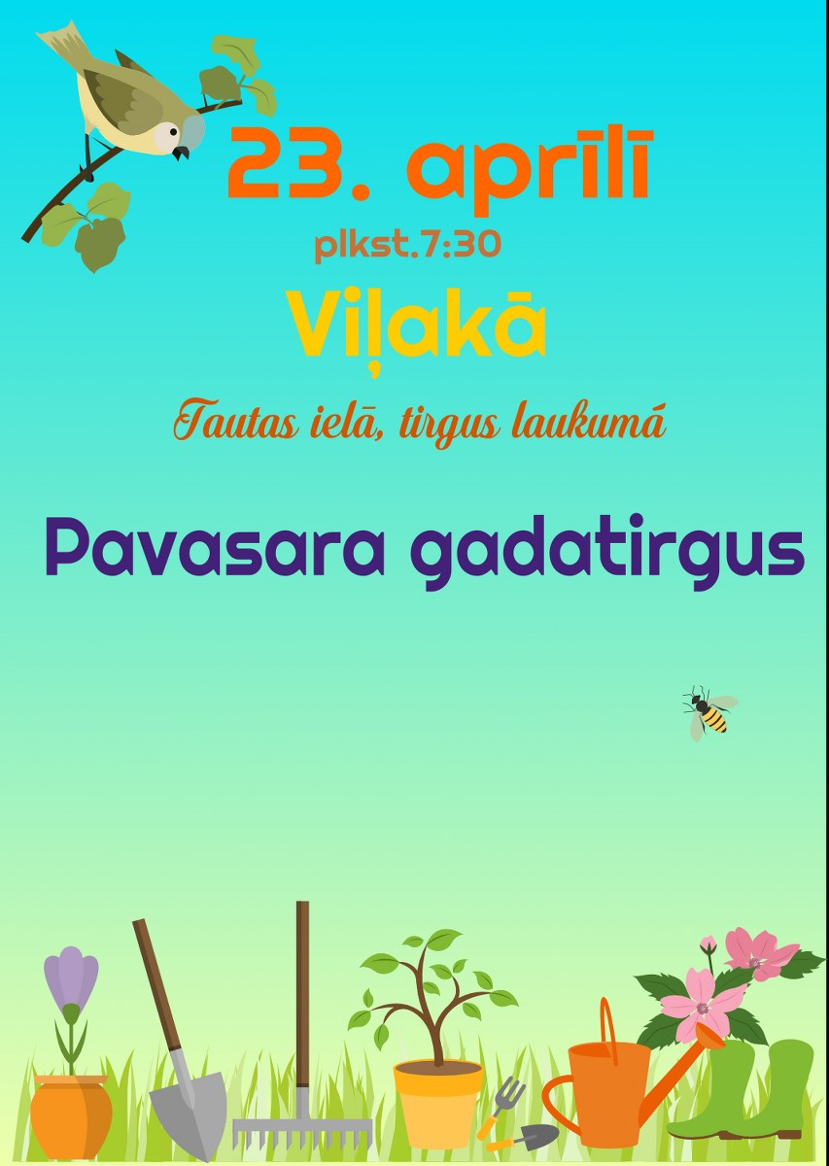](http://vilaka.lv/uploads/images/Afisas/tirgus_Vilaka_23.04.2016_853x1200.jpg)