International conference
Rural Space Development and CLLD
12-13 September, Valmiera

Route No. 1. Limbaži circle

* Registration at 9.30, departure at 10.00
* From the hotel Tigra. Address: Eduarda Veidenbauma Street 2, Cēsis / Priekuļi, Priekuļi parish, LV-4126.
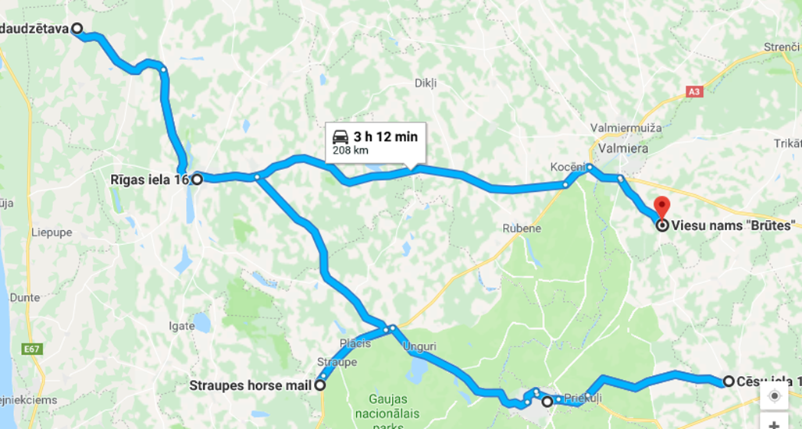
We inform you that during the event you may be photographed, filmed, recorded on audio or video.
I agree to the processing of my personal data and information, including data storage, in the Latvian Rural Advisory and Training Centre’s database in accordance with the requirements of Regulation (EU) 2016/679 of the European Parliament and of the Council on the protection of natural persons with regard to the processing of personal data and on the free movement of such data (General Data Protection Regulation).

1. SIA Latnature: company produces crisps from berries and fruit.
LEADER project Address: Cēsu Street 10-1, Rauna, Rauna parish, LV-4131.
With the support of the organisation Cēsis District Rural Partnership two projects have been realised to improve SIA Latnature’s factory.
SIA Latnature was established on 19 November 2015 in Rauna by creating a factory which started producing vegetable crisps (beet, carrot, celery, pumpkin, kale) and vegetable crackers (beet, carrot, celery).
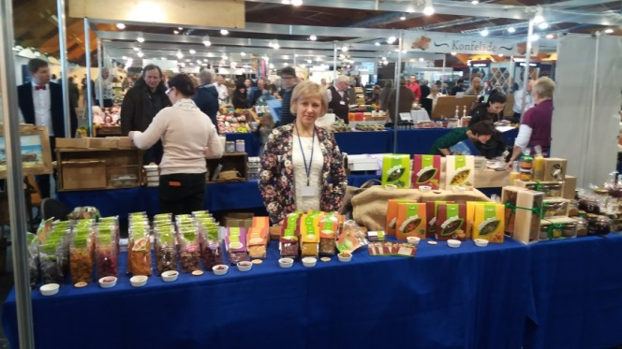
The first project for improving SIA Latnature’s factory was realised at the end of 2016.
SIA Latnature’s factory was improved by purchasing a fruit dryer and a vegetable slicer with two types of discs for slicing to increase the production scope and to diversify the assortment, thus promoting the creation of new products and using local resources productively. SIA Latnature’s factory motto is: “natural ingredients, naturally dried”. SIA Latnature produces tasty and healthy products without preservatives, gluten, or sugar. Vegetable crisps and crackers can replace the commonly consumed treats and supplement daily food flavours. Vegetables are sliced, seasoned with savoury and natural spices, and then slowly dried in 45 degree temperature, thus preserving the healthy qualities of vegetables. Because the factory is new, vegetables and ingredients were purchased in wholesale warehouses. But after realising the project and purchasing powerful equipment, vegetables, berries, and herbs were purchased by signing agreements with the local Latvian farmers.
Total project sum: 3,436.35 euros, project public financing sum: 2,405.44 euros.
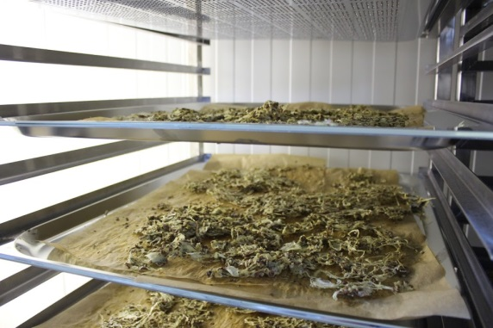 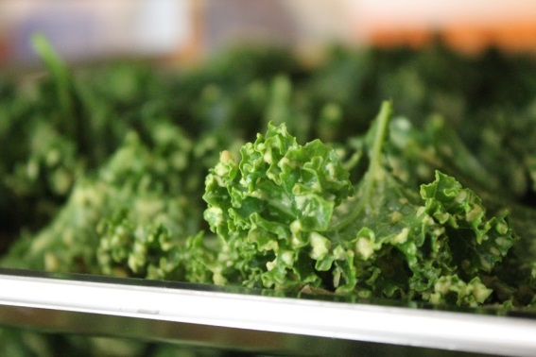
The second project for improving SIA Latnature’s factory was realised at the end of 2017.
During the project, a spacious fruit dryer with 11 shelves and a powerful vegetable slicer with two additional discs for slicing were purchased.
Now, besides vegetable crisps and crackers, the factory produces fruit and berry biscuits, fruit-honey rolls,

and new products: fruit truffles with honey, onion crisps, onion crisp-bread, pumpkin crisps with penny buns. The demand for the products has grown; by purchasing more powerful equipment, the growing demand for the healthy produce, which is demanded in many eco product shops, is met. SIA Latnature’s produce can be purchased in Rauna, Cēsis, Valmiera, Sigulda, Mārupe, Jelgava, and many other locations in Latvia. SIA Latnature also organises excursions in their factory with product tasting and master-classes.
Total project sum: 12,841.62 euros, project public financing sum: 8,193.63 euros.
Additional information:
http://www.rauna.lv/turisms/tourism/latnature-ltd-vegetable-crisps-manufacturer
https://www.facebook.com/Latnature/

2. Straupe Stage Coach
LEADER project
Address: Vecpasts, Straupe parish, Pārgauja district, LV-4152.
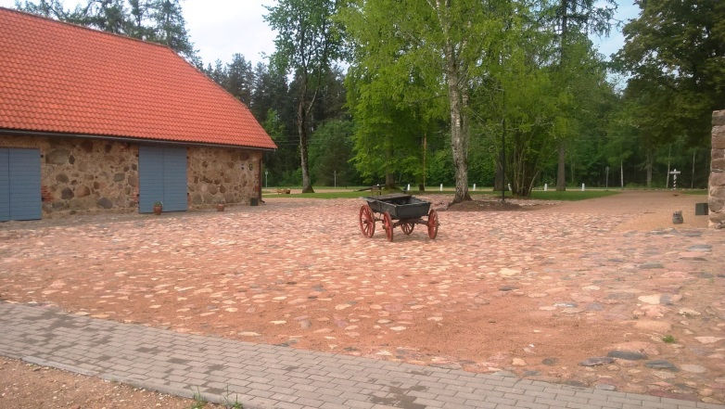
Two LEADER projects realised.
Project The Reconstruction of Straupe Stage Coach Courtyard to Ensure Accessibility
Ensuring horse post accessibility for older people, people with movement disorders, and people in wheelchairs and with baby carriages by adjusting the cultural-historical pavement of the complex and by ensuring access to lavatories. Renewal of the rock pavement and construction of a door junction are planned.
Project public financing: 17,085.09 euros.
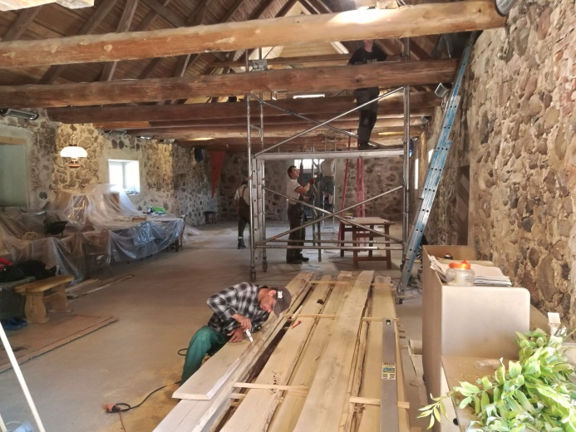
Project The Reconstruction of Straupe Stage Coach stable to Create a Modern Economic Cultural Centre.
To create the unique Lielstraupe horse post in Latvia: a modern exhibition, seminar and concert hall by reconstructing the stable as the first of the several Lielstraupe horse post complex buildings, accessible for 12 months a year. The stable reconstruction is planned for 220 square metres.
Project public financing: 32,972.33 euros.
Additional information: https://zirgupasts.lv/

3. Limbaži historical centre
ERDF (Investment and Development Agency of Latvia) project
Address: Burtnieku iela 4, Limbaži, LV-4001.
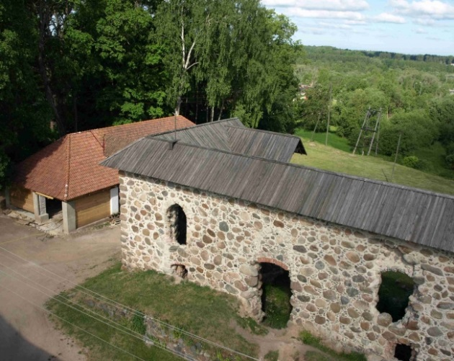
Project The Renovation of Limbaži Historical Centre for Tourism Development
During the project, a part of the state town planning monument was reconstructed: the old town hall in Burtnieku Street 4, Limbaži castle manor and the castle ruins in Burtnieku Street 7, thus creating a quality tourism offer and ensuring the preservation and promotion of Limbaži town cultural heritage. By realising the project new tourism options are offered: 18th century mural which can be viewed in the old town hall, 19th century household buildings, and the reconstructed Limbaži castle ruins ground floor (or the 1st floor) space.
Total project support sum: 522,100.74 euros.
Additional information: http://travelnews.lv/foto/?gid=3891&iid=72813

4. SIA Krogzeme, black currant grower
Rural Development Program (RDP) project
Address: Krogzeme, Nursery, Vīnkalniņi, Limbaži district, Ķirbiži, LV-4050.
SIA Krogzeme began operating in 2009 as a decorative plant nursery. But since 2011 they have specialised in the black currant commercial gardening business: they grow black current plants, lay out black currant commercial gardens, improve black currant cultivation technologies by cooperating with Latvian and foreign scientists, develop business plans for black currant commercial gardens, and also consult all people interested in the business. They are proud that they are the only nursery in Latvia that offers certified black currant varieties.
From 2010 until 2017, they have realised five rural development programme projects by purchasing different equipment, which allows to develop the nursery, for example, tractors, power harrow, plough, irrigation equipment, etc.
They have participated in the rural development programme’s sub-activity 16.2 Support for the Development of New Products, Methods, Processes and Technologies with the project Black Currant Biological Fertilisation Methods. The project is planned to start in 2019.
Additional information: https://www.latvijasupenes.lv/home/

International conference
Rural Space Development and CLLD
12-13 September, Valmiera

Route No. 2. Smiltene circle
* Registration at 9.30, departure at 10.00
* From the hotel Naktsmājas (address: Vaidavas Street 15, Valmiera)
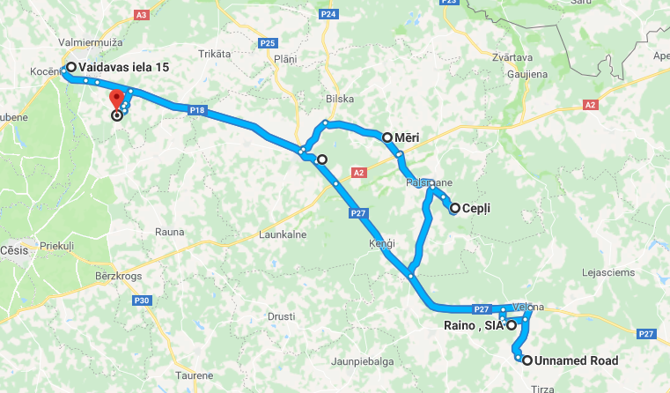
We inform you that during the event you may be photographed, filmed, recorded on audio or video.
I agree to the processing of my personal data and information, including data storage, in the Latvian Rural Advisory and Training Centre’s database in accordance with the requirements of Regulation (EU) 2016/679 of the European Parliament and of the Council on the protection of natural persons with regard to the processing of personal data and on the free movement of such data (General Data Protection Regulation).

1. Dairy farm Kalējiņi 1
Intensive investments into farm development.
RDP project
Address: Mēri, Bilska parish, LV-4706.
The farm was established in 1996. Its owner Kaspars Putrālis was then only 26 years old. By acquiring professional skills in the Latvia University of Life Sciences and Technologies and by participating in training organised by the Latvian Rural Advisory and Training centre, Kaspars acquired enough knowledge to bravely tackle the development of a large dairy farm. From the initial 14 milch cows their herd has grown to 315! Regarding productivity indicators, this is the fourth best herd in Latvia.
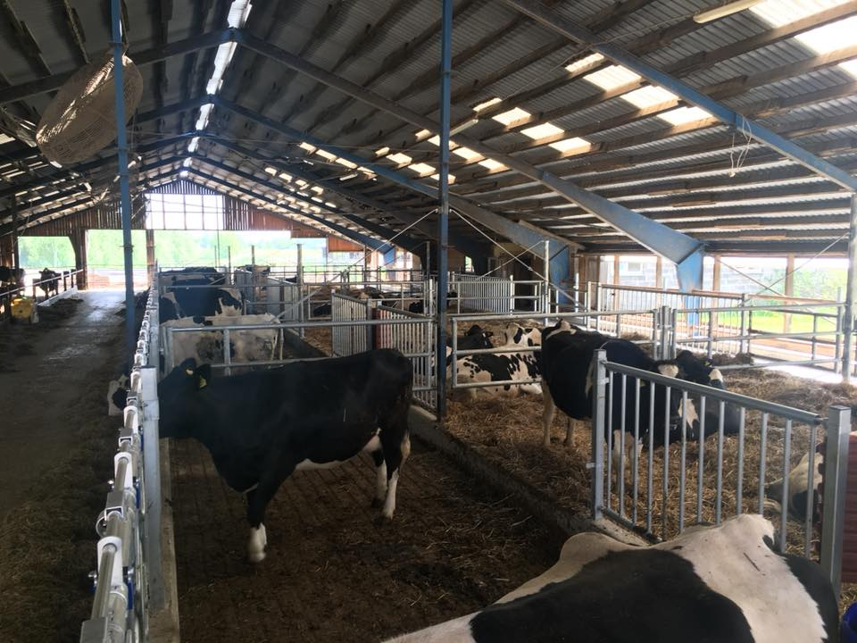
The farm has realised more than 10 EU supported projects: a modern stall, a rotary milking parlour, a concentrated feed factory, a shed for young cattle have been built, 17 new units of equipment have been purchased. Now we can regard the farm Kalējiņi 1 as a knowledge base for new entrepreneurs who operate in dairy farming development.
Additional information: https://www.facebook.com/kalejini1/

2. Farm Veccepļi
Apple growers, juice producers.
LEADER project
Address: “Cepļi”, Palsmane parish, LV-4724.
Two LEADER programme projects.
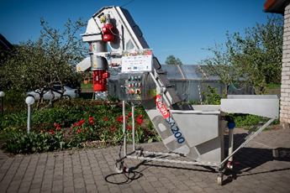
Project The Purchasing of Fruit Washing and Chopping Equipment.
Fruit washing and chopping equipment has been purchased, which significantly facilitates production, raises productivity, and offers the possibility to focus on creating new products: to produce currant and black currant juice and to dry apples.
Project sum: 8,548.00 euros, EU Rural Development Fund: 4,945.12 euros.
The other LEADER project has been confirmed, it is set to be completed in December 2019.
Project The Construction of a Juice Refining Station
The goal of the project is to build a juice refining station, which will significantly facilitate production, raise productivity, and offer the possibility for producing different juice mixtures.
Project sum: 80,000.00 euros, eligible costs: 50,000.00 euros, from them EU Rural Development Fund public funding: 35,000.00 euros.
Additional information: https://aboli.lv/

3. SIA Tālavas ķēniņa alus
Beer brewery.
LEADER project
Address: Kāmieši, Lizuma parish, Gulbene district., LV-4425.
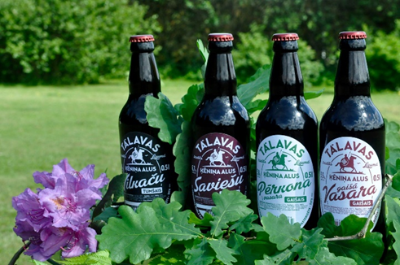
SIA Tālavas ķēniņa alus was established in 2012, but the company started producing beer in 2014. The entire beer brewing process in Tālavas ķēniņa alus is done by hand. It is important to note that the beer is brewed on a farm. The factory has been established in what was once a stone cattle-shed, but had been left empty for a long time. Now the thick stone walls help ensure an even temperature in the brewery in both winter and summer, which is very important for brewing beer.
One room has a small malt mill and stores bags of barley ready for preparing leaven. The largest room in the brewery is for boiling wort and fermenting beer.
The company has realised two LEADER projects.
Owing to the projects, the company has added to their material-technical base, has purchased different equipment (for cooling, labelling, vacuum packing, etc.), has oaken barrels and other types of barrels, washing and sterilisation equipment, etc.
During the second project, fruit processing equipment was purchased. Also, during the project, a specially equipped truck for transporting products was purchased.
Project eligible costs: 23,655.17 euros, from them EU Rural Development Fund public funding: 16,558.62 euros.
Additional information: http://www.talavas.lv/#

4. SIA Smiltene Impex
ERDF (Investment and Development Agency of Latvia) project
Address: SIA Smiltene Impex, Silvas sawmill, Launkalne parish, Smiltene, LV-4729.
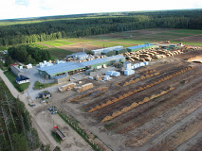
First project: The Purchasing of Electronic 3D Survey Equipment and the Implementation of an Automation System for Calculating in SIA Smiltene Impex to begin manufacturing new products.
In result of the project, SIA Smiltene Impex introduced new technological processes,
which will allow for the manufacturing of new products: furniture templates, profiled planed planks for lining and flooring, planks without core. Also, significant improvements were made in product quality, added value, and profitability. To ensure that, during the project, roundwood electronic survey equipment with an automatic control system and programs was purchased and implemented into manufacturing, along with licences for an automation system for manufacturing and calculating.
Project support sum: 73,779.99 euros.
The second project: Changing Sawing Technological Process by Implementing New Technologies to Increase Added Value.
During the project, a technological line for roundwood sawing, a technological line for side plank lining, an electric and electronic control system for equipment and transporting equipment for side plank and loose wood product transportation, and a sawing and lining equipment metal sub-construction have been purchased and installed.
Project support sum: 1,068,905.52 euros.

International conference
Rural Space Development and CLLD
12-13 September, Valmiera

Route No. 3. Valmiera circle
* Registration at 10.30, departure at 11.00
* From the hotel Volmārs (address: Tērbatas Street 16a, Valmiera, LV-4201).
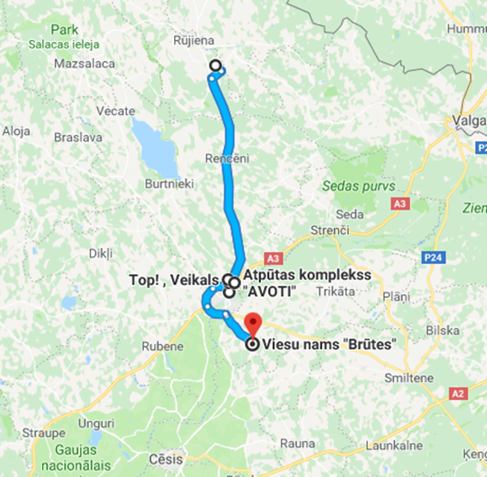
We inform you that during the event you may be photographed, filmed, recorded on audio or video.
I agree to the processing of my personal data and information, including data storage, in the Latvian Rural Advisory and Training Centre’s database in accordance with the requirements of Regulation (EU) 2016/679 of the European Parliament and of the Council on the protection of natural persons with regard to the processing of personal data and on the free movement of such data (General Data Protection Regulation).

1. Dairy farm Ceriņi
RDP project
Address: “Ceriņi”, Jeru parish, LV-4234.
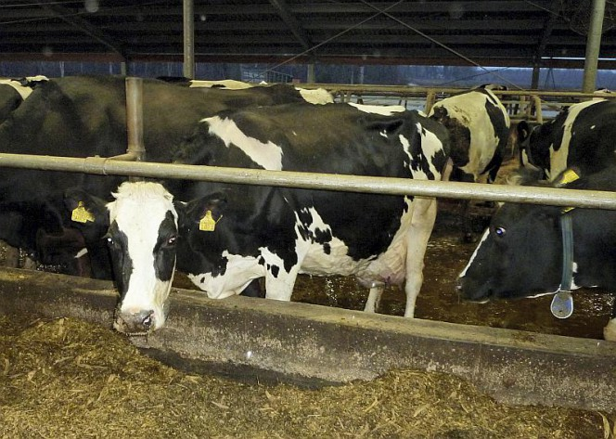
Photo from farm Ceriņi archive
The farm Ceriņi began farming in 1990 with purchasing the real estate property Ceriņi: a dwelling house, a barn, and a household building. The first year was spent renovating the household building by own efforts to place cattle. Then the farm only had three cows and two young cattle.
At the end of 1997, it was decided to reconstruct the farm by using ideas acquired in Germany. In 1998 this was accomplished, the cattle-shed was reconstructed into a freestall for 90 cows. In 2000, the farm got its second breath when welcoming their first bred HM cross milch cows. In result, from a weak Latvian Brown cow herd, which produced 20 litres of milk daily, in these more than 20 years, one of the best herds in the country has been perfected with the average annual milk yield being over 14,000 kg per cow, and the average daily milk yield reaching 45 kg per cow.
Now the farm Ceriņi manages 272 ha, of which they own 230 ha. The herd, which in 2015 was recognised as the most productive in Latvia, now has 276 cows and 238 young cattle of different ages (heifers for growing). In 2015, the average milk yield per cow surpassed 14,000 kg, in a day the farm produces over 10 tons of milk.
The farm has realised six projects with EU support with the total costs being 3,229,648 euros, from which EU financing is 1,688,240 euros.
Additional information: https://www.facebook.com/zsCerini/

2. SIA Valmiermuižas alus beer brewery
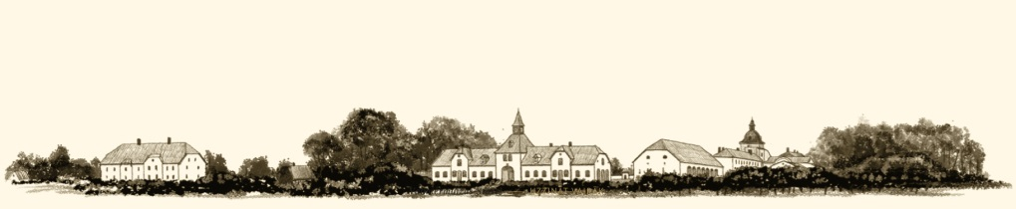
LAP, ERDF (Investment and Development Agency of Latvia) project
Address: Dzirnavu Street 2, Valmiermuiža, Burtnieku district.
In 2009, the company begins operating based on ancient traditions.
The brewery has realised two Investment and Development Agency in Latvia projects from ERDF and several Rural Development Programme (RDP) projects.
Investment and Development Agency in Latvia project:
Creating a Beer Brewery According to the Requirements of the Work Safety Legislation.
The goal of the project: to build a beer brewery and purchase equipment to begin producing beer.
Project support sum: 845,185.85 euros.
Building a Connection for SIA Valmiermuižas alus Beer Brewery.
The goal of the project: by building a connection to the engineering network promote the company’s competitiveness (using gas lowers technological costs, a connection to a centralised sewerage system decreases risk to the surrounding environment, a local water supply system significantly lowers water acquisition costs).
Project support sum: 303,177.34 euros.
From 2012 until 2015, three RDP projects have been realised under the activity Creating Added Value for Agricultural Products.
Different equipment has been purchased to promote business, for example, a sterile filter, KEG barrel washing and filling equipment, a steam generator, a mixer, a pasteuriser, filling equipment, label gluing equipment, CO2 reservoir site construction, and a case washer.
Total costs: 46,474.35 euros.
From 2017 until 2018, two RDP projects have been realised under the activity Investments into Material Assets.
During the projects, different equipment has been purchased, for example, a beer brewery, a set of technological equipment for improving drink quality, digital beer analysers, CCT tanks, laboratory equipment, bottle loading equipment, a sewage pre-treatment system.
Additional information: http://www.valmiermuiza.lv/en/

3. BMX track and museum
LEADER project
Address: Avoti, Valmiera parish, Burtnieku district.
The goal of the BMX sports club Tālava (Burtnieki district) is to promote and develop the sport in Vidzeme and in Latvia, to achieve high scores in the sport, to organise sport events, Latvia’s BMX participation in the Olympic Games. The sports club Tālava can be proud of the highest scores in BMX: Beijing and London Olympic champion Māris Štrombergs, world championship silver medalist and a four-time European champion Ivo Lakučs, two-time world champion and two-time European champion in junior race, European champion in the elite group Artūrs Matisons, and new BMX stars, Edžus Treimanis and Kristers Lejiņš.
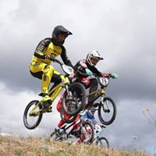
The goal of the project was to create a BMX track that complies with the Olympic standard and allows Latvian athletes to fully prepare for their participation in the Olympic Games. During the project, the existing BMX track was reconstructed by adding an Olympic standard start scaffold bridge (a precise copy of the start scaffold bridge in the Olympic Games), the first starting line and a curve that connects to the previously constructed BMX track.
Total project financing: 28,147.25 euros, from it LEADER financing: 25,331.38 euros.
Additional information: http://www.bmxtalava.lv/en/sco-centrs-bmx-velotrase

4. SIA Woodheart
LEADER project
Address: Burtnieku district, Valmiera parish., Valmiermuiža, Alejas Street 12/3, LV-4219.
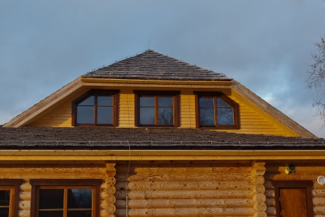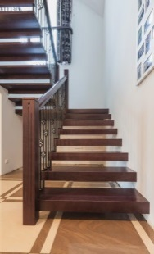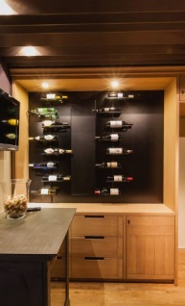
SIA Woodheart was established on 7 February this year.
The company specialises in manufacturing windows and design furniture. The company was appropriately named Woodheart. The name characterises the business’ ability to see the wood’s unique beauty created by nature and, by putting in their work, creativity and skills, manufacture useful things.
For the company to start manufacturing with enough power and competitiveness, it was decided to participate in the LEADER project competition. The acquired financing ensured successful development for the new company and allowed to achieve ambitious goals: to manufacture quality and high-value wood products in the company for both exporting and the local market according to individual orders.
Machines and precise woodworking equipment were purchased. Now the company produces wood windows with high heat resistance and wood windows with outside aluminium cover plates, also, it manufactures design furniture, stairs, street doors, and other products according to individual orders.
Project sum: 49,634 euros, project public financing sum: 34,615 euros.
The company has developed so much that it needs to improve the work environment and rational product use. The issue with the use of manufacturing leftovers must be solved.
A second LEADER project has also been submitted, the goal of which is to, by purchasing the necessary equipment, ensure further development of the company by manufacturing high quality products and by significantly improving the work environment, to become an environmentally friendly company, which takes care of the manufacturing leftover chip recycling and rational use.
Total project sum: 41,322 euros, project public financing sum: 28,952 euros.
Additional information: http://woodheart.lv/?lang=en

